Tuesday, 1 September 2026, postcard

Tallahassee to London

Once again, the complimentary limo arranged by our travel agent (who really likes us now that we're spending more money on travel) arrived on the dot for our trip to the airport. Driver Daniel proved an interesting conversationalist. He took us what we considered the long way round to the airport but which proved (as he predicted) to be the quicker route. After dropping us off, he headed back downtown to pick up our flight crew from their hotel.

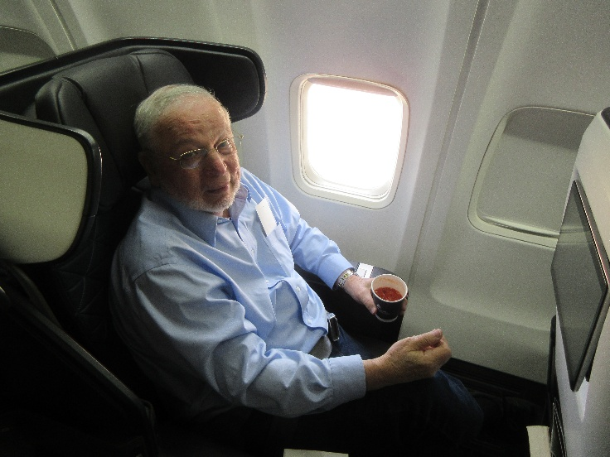
Our flight boarded and departed on time, and we were absolutely delighted with the new first-class seats Delta had installed in our plane. We were (I'm almost embarrassed to admit it) flying first class, even for the hop to Atlanta, so we never saw the seats in the main cabin, which may bave been the same-old-same-old, but ours were terrific! We weren't the only ones to comment; the captain actually came out of the cockpit to give us a little lecture on them. They were apparently designed by a guy who designs race cars (or at least the seats in them). Besides being wide, capacious, and comfortable, they featured many details that showed some thought had gone into them. For example, the head-phone jack is now next to your elbow (my left, as I was in the aisle seat on the port side of the center section). As a result, if you're in the aisle seat, and the person in the window seat wants to get out, you no longer have to disconnect and reel in the cord to your headphones so he can get by. Behind my elbow was the little panel with USB jacks and a regular wall-type plug. Near it was a slot in which your phone could sit while charging; it was even big enough to accommodate a kindle or tablet. Set into the wall below the broad armrest that separated me from David (in the window seat), was a larger slot in which I could put my book, glasses, pencil, etc. while I adjusted my seatbelt or fished for something in my purse. It included a round well just the right size to accommodate an 8-oz bottle of water. For years, whenever we happened to be in first class, we've boarded to find a pair of such 8-oz bottles waiting for us on the slippery little armrest tray. Then, if you didn't keep a firm hand on yours, as soon as the plane made its first turn during taxi (or later, when you hit rough air), it would launch itself into the aisle and roll around under the seats for the rest of the flight. Now, you can simply drop it into its secure little well, leaving the armrest tray (now coated in nonskid material) free for the drink you order from the stewardess. Between the two seats in front of us were a pair of tall slots with enclosed bottoms where you could put other things—books, magazines, newspapers, a cane, even a folded umbrella. If they just put a little hook at the top of each one, it would be perfect for a suit jacket or light coat. On the seatback in front of us, a tiltable video screen (even on a flight that barely allows time to watch a half-hour sitcom episode). Finally, each padded headrest could be slid up and down to accommodate taller and shorter passengers, and the sides of it could be bent inward to support your head if you fell asleep. Nice.

In Atlanta, our arrival and departure gates couldn't have been farther apart—T4 and F2, respectively—but we had a long layover, and we'd arranged for wheelchair transfer (because of David's continuing difficulties with walking any distance), so we just chatted with the pushers all the way to the food court on Concourse F, then went to Ecco for lunch.

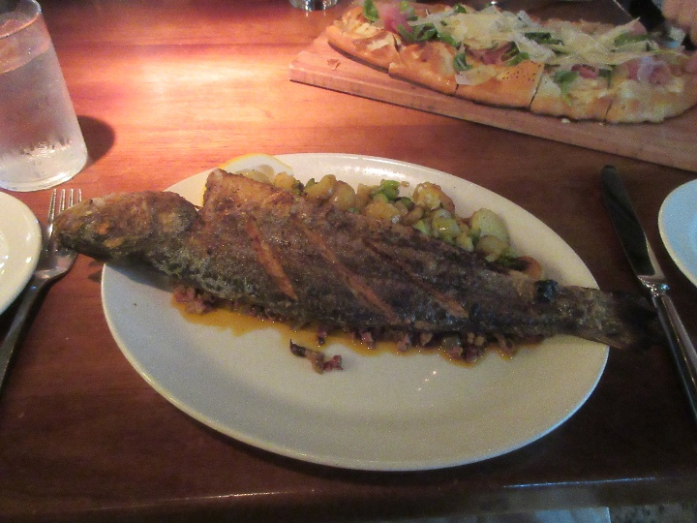
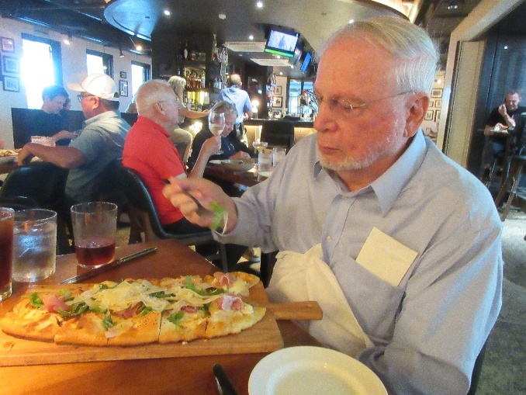
Ecco has improved drastically since that tough, dry octopus tentacle they served me on our first visit. David ordered the "prosciutto flatbread," which was larger than he could finish, but I went for the whole grilled branzino (Dicentrarchus labrax), served over a bed of olive tapenade and accompanied by creamy sliced baby potatoes and asparagus. Not quite the equal of the chargrilled one I had in the restaurant above the fish market in Aveiro, Portugal, in 2015, but darn good all the same! I can't believe I ate (almost) the whole thing.

Then we sat in the Delta lounge on our concourse, waiting out our long layover, taking advantage of the free coffee and little chocolate pudding parfaits off the dessert buffet and being deafened by sirens followed by a very loud recorded announcement that "An emergency has been reported in the building. While this is being verified, please stand by for further instructions" over and over again.

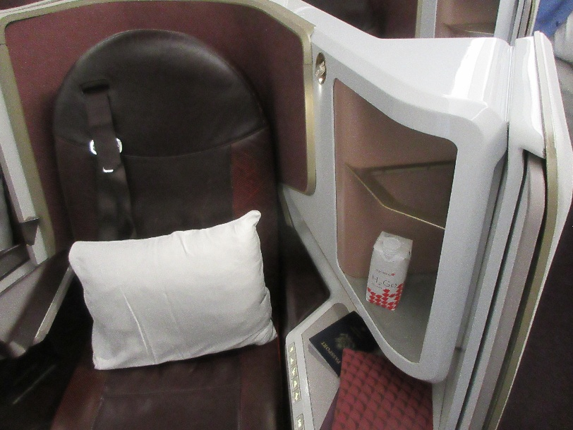
This would be our first flight operated (on behalf of codeshare partner Delta) by Virgin Atlantic, and were agog to learn what it's first-class seats would be like. Quite impressive, as it turns out.

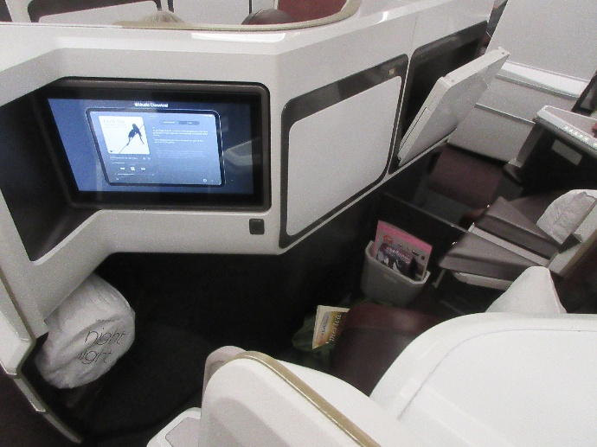
Here's the view of mind from the aisle. The red and white object is a "juice box" of mineral water. Of the five lighted seat-control buttons visible at the bottom center, only two actually worked—the one flattening the seat in to a level bed and the one reversing the process. Fortunately, both could be stopped at any point partway. The video screen folded back out of the way as shown here, but could be popped out at the push of a button to face the passenger. The table folded out of the "wall" in front of you—you can see that of my neighbor partly folded out. Then a portion of it could be slid out sideways to make it wider. The white object at the lower left corner is a rolled-up quilt in its own stuff-sack. I never unrolled mine, as I never got cold.

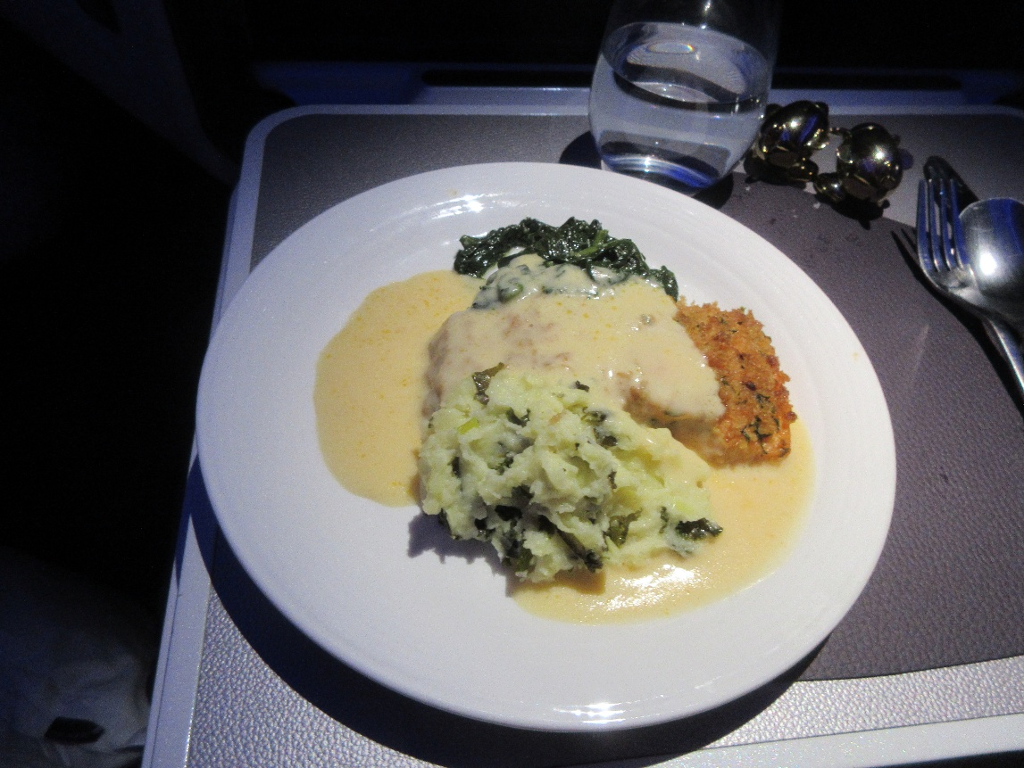
The only serious glitch on the flight was the total lack of running water in either the restrooms or the galley. The crew apologized profusely for being unable to make any hot beverages (apparently they had no way to heat bottled water, of which fortunately they had plenty). They stocked the restrooms with hand sanitizer and hoped for the best.

I watched a couple of movies, during which I ate dinner (pretty good, although the salmon was of course overcooked), then turned off the screen and pretended to sleep for a few hours.

